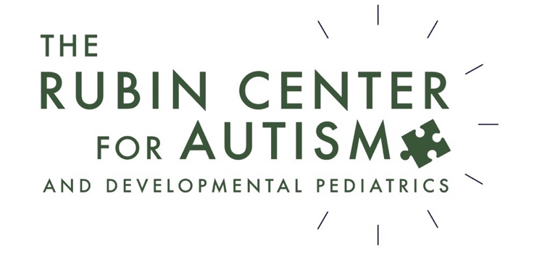
Consent for use and disclosure under Health Insurance Portability and Accountability Act of 1996 (HIPPA)

Your signature below represents consent for Rubin Center for Autism and Developmental Pediatrics to use and/or disclose information about you and/or the patient (or another person for whom you have authority to sign) that is protected under federal law, for the sole purposes of treatment, payment, and health care.

By signing below you acknowledge that you understand your rights under HIPPA. You may request a copy of your HIPPA rights and/or Rubin Center for Autism and Developmental Pediatrics policies at any time by either requesting it by phone or through email.

Privacy will be protected based on the policies through HIPPA as well as any exceptions that have been established by the patient/guardian and/or guarantor. All requests for release of protected information needs to be requested in writing. We are not able to process verbal requests for the release of protected health information.

___________________________________________________________________
Patient’s Full Name and Date of Birth

___________________________________________________________________
Print Name of Guardian/Guarantor (if different from patient)

__________________________ __________________________
Signature of Guardian/Guarantor Relationship to Patient

